Day one home learning- Willow Class

Maths:
Arithmetic-Work through the questions. Remember; don’t forget to show your workings.
Purple Mash- set activities
Literacy:
Pobble Picture
Inference-Use the image to answer the questions provided. Please answer in full sentences and explain your answer.
Short narrative or poem
Art:
Drawing small- find a range of small items (penny, paper clip, nail, pasta). Watch the video below to help you with the techniques and strategies when drawing to a small size. Think about size and shading- enjoy!
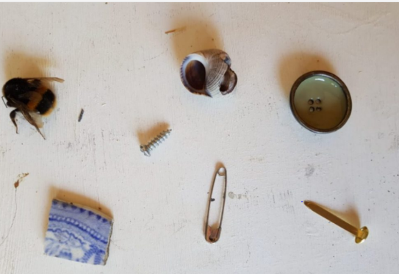
Drawing Small (accessart.org.uk)
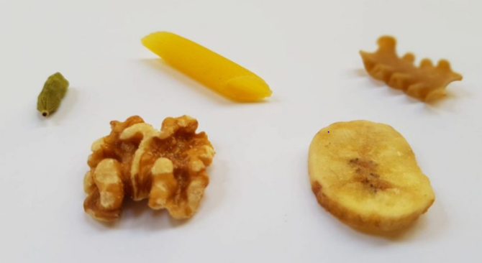
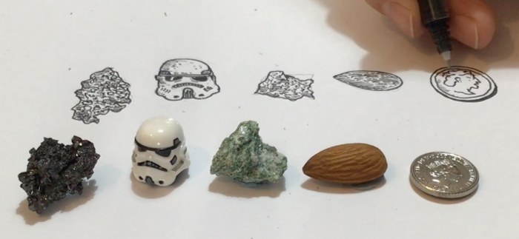
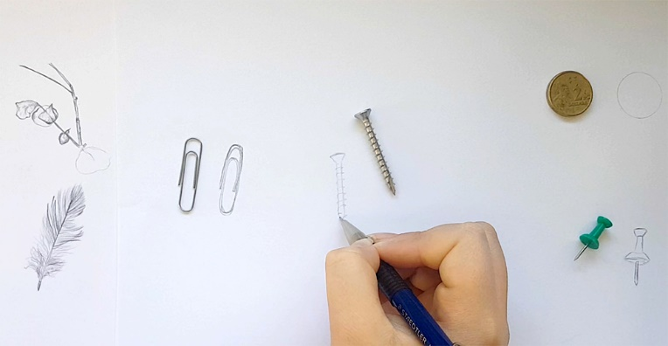

Yoga Time:
Click on the link below to take part in Mrs Perkins’ Yoga session- enjoy!
As always, I am only an email away. Just try your best with the above tasks and I will be in contact with your weeks work.
Best wishes, Miss Grantham

