Home learning – Wednesday 6th January 2021
Good morning:
Today it is Wednesday 6th January. See if you can write this on a piece of paper!

Morning task:
Reception: Please practise saying and writing the letters on your phoneme card. Can you remember all the actions?
Year 1: Please read and write out your spellings for the a_e split digraph. These are attached with a clip of how to read the words.

Session 1: Please work on paper. You will receive a writing book as part of the home learning pack (which you will receive by Friday). Please stick your work into this.
English (London): Talk about You Tube clip which was set for day one of home learning (or watch it if you haven’t had a chance yet). Look at the pictures of London attached.
Show the clip of Katie in London (on the class Home learning webpage) read by Miss Blake
Task:
Reception: Draw and label pictures of where they might visit
Year 1: Draw and write at least two sentences about where they would visit. Start your sentence ‘Grandma, Katie and Jack went on the big red bus to see’

Session 2: Please work on paper. You will receive a writing book as part of the home learning pack (which you will receive by Friday). Please stick your work into this.
Maths:
Number song (YouTube) The Big Numbers Song - YouTube
Using number line to count to 20 and back
Show/point to numbers in any order for recall (to 5 or 10 if 20 too high)
Show number of fingers – when adult says eg show 4, now 1, now 7 etc
Watch Number blocks series 3 Ep 5 – Zero BBC iPlayer - Numberblocks - Series 3: Zero
Reception: see attached ‘zero’ Power Point

Year 1:

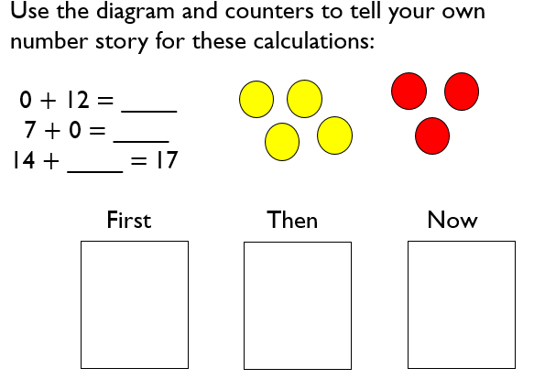

Eg. First there was 0 then 12 is added and now there is ___ (12)
First there is 7, then 0 (zero) is added and now there is ____ (7)
First there is 14, then there is ____ (count on from 14 to 17), now there is 17.

Click on the link below to access First Then Now problems to talk through
https://classroom.thenational.academy/lessons/to-add-by-counting-on-using-a-number-line-ccukct?step=2&activity=worksheet

scroll down to where it says ‘show slide 1’ – click on the down arrow to show more problems

Children to record as ___ + ___ = ____
We call this: part plus part is equal to whole

Session 3: Forest school:
Look for signs of winter in the garden, out of the window or when you go out for a walk.
Tasks:
- Make a snuggly den for an animal
- Get an old plate and find natural things to place in it. Cover it with water and leave out overnight. In the morning see if it is frozen. Can you place it somewhere in the garden. Try it again and add some string or ribbon to the plate. When it is frozen, see if you can hang it somewhere!
Please send us photos!

Enjoy your day.

Miss Blake & Mrs Evans

