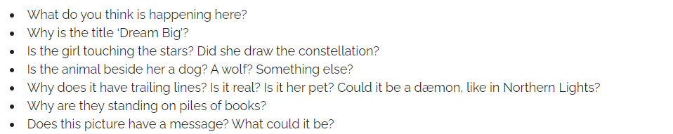
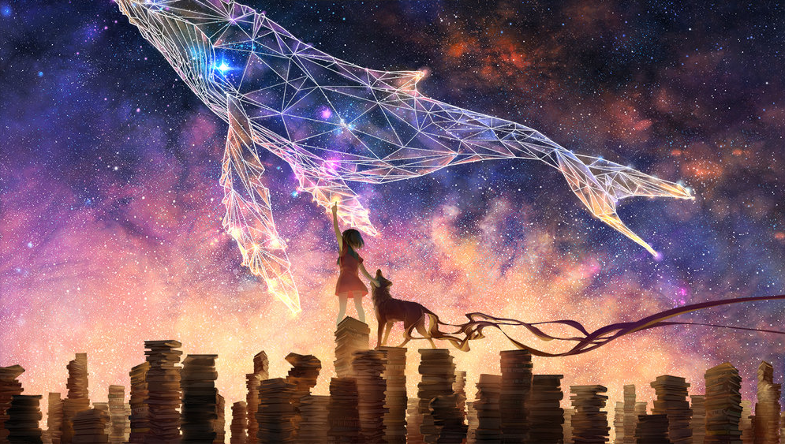
DREAM BIG!
Use this image to creative a short narrative or a poem. Don’t forget your key pieces of punctuation and descriptive languages.

