Week Commencing  01.02.21 | Monday | Tuesday | Wednesday | Thursday | Friday
Maths  Investigation week: Uploaded is a booklet of your investigations for the week. | MAGIC Vs  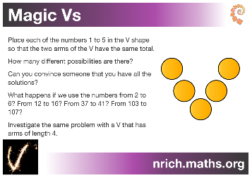  See the maths booklet for your session guidance. | ICE CREAM MATHS  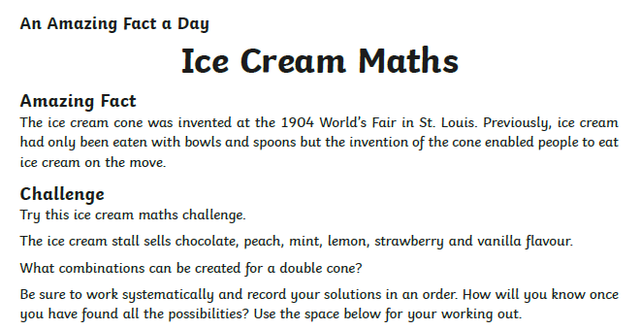 | 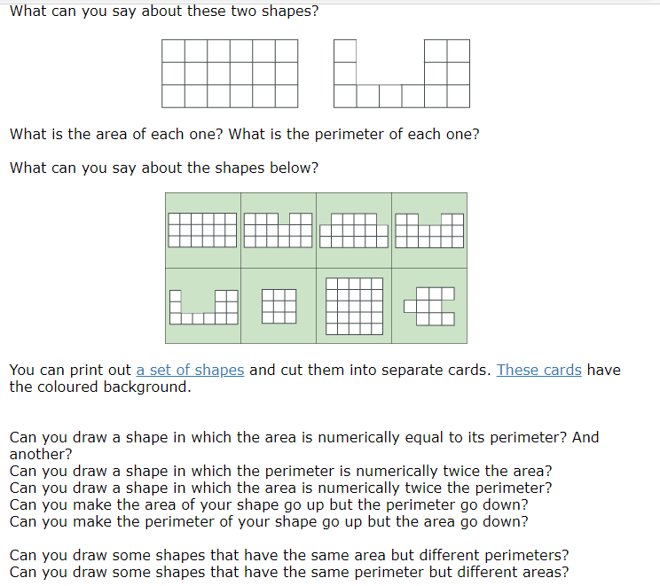  AREA and PERIMETER | Arithmetic  We do this weekly in class, so to keep in our routine we will be continuing with this every Thursday morning | This week we are setting you the challenge of making a ‘spaghetti Bridge’  Challenge Cards (jamesdysonfoundation.co.uk)
Literacy | Anglo Saxon Jobs  A tour around an Anglo-Saxon settlement - KS2 History - BBC Bitesize  Saxon life at West Stowe - KS2 History - BBC Bitesize  Watch the PowerPoint up to slide 3 – then we want you to find out more about one of the Anglo-Saxon jobs you have learnt about.  Use the sheet provided to help you make notes! | Anglo Saxon Jobs  Today you are going to create a poster to advertise for an Anglo-Saxon worker for your job- how exciting!  We would like you to draw a picture of an Anglo-Saxon worker doing the job you have chosen in the middle and provide details about the job and the qualities needed to do it in the boxes around the outside. | Anglo Saxon Village Life  Watch power point slides 4 and 5 and then do the following activity.  Using all the information you have learnt about what an Anglo-Saxon village was like, can you now design and draw your own village?  If you do this properly it will take you both today and tomorrows session. You may do some extra research if you choose to.  You should try to include as many features as you can to make sure your village is busy and thriving! | Anglo Saxon Village Life  Carrying on activity from Wednesday  You will also need to write labels to annotate all the features of your village and show you understand what it was like to live there.  Please see the support sheet to help you with this!
Afternoon Activity/Activities | TOPIC  ‘Children’s Mental Health Week’  Expressing yourself through creativity. This could be through art, music, writing and poetry, dance and drama, photography and film. The aim of today’s session is to do something that makes you smile.  Don’t forget to send a photo of your ‘feel good’ activity. | P.E.  It's Yoga time - SIBFORD GOWER ENDOWED PRIMARY SCHOOL (sibford-gower.oxon.sch.uk)  Now you have finished your yoga session. Time to dress to express!  Pick an outfit (it can be as crazy as you like) that shows your lovely and unique personality.  Take a photo- I cannot wait to see you! | TOPIC  Following on with the ‘expressing yourself through creativity’ theme,  We would like you to look at the PowerPoint. When you have done this, go back to slide 7 and use this as inspiration to create your own piece of art work using whatever materials you choose. | French  Click on the link below for your French lesson with Mr Cameron  French & Music - SIBFORD GOWER ENDOWED PRIMARY SCHOOL (sibford-gower.oxon.sch.uk) | Global Learning  Have a look at the newspaper and photo questions. Have a discussion about what is going on in the picture.  Don’t forget this is all uploaded on to your purple mash portal!  Class book

