Week Commencing  01.03.21  This week we are celebrating | Monday | Tuesday | Wednesday | Thursday  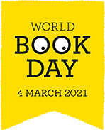 | Friday
Maths | Shape – Nets  Following on from last week’s maths, I would like you to have a look at 3D shapes and their nets.  - Watch the PowerPoint to help with your learning  - Match up game- match the 3D shapes to their nets  - Have a go at making some 3D shapes using the nets provided.  CHALLENGE- draw a net for your own 3D shape | Lines- Different types of lines.  Please watch the PowerPoint to support your learning.  - Line sheet (purple mash)  - Line hunt- how many different types of lines can you find in your house/garden? | Arithmetic  We do this weekly in class so to keep constituently we will be continuing with this but on Wednesday this week as it is World Book Day tomorrow | World Book Day Activities  World Book Day Competition - Coram Beanstalk & Very.co.uk  1.Watch Mrs Humphreys Video on our home learning page for guidance and read the uploaded flyer that is on purple mash.  World Book Day – live lesson  At 11:30 there is a Live lesson linked to World Book Day – follow the link below  World Book Day 2021 - Live Lesson - BBC Teach  We have also uploaded parent guidance and resource sheets to do throughout the lesson. | Spellings  Science  ‘Measure the speed of light’  JDF-challenge-cards-JULY20.pdf (jamesdysonfoundation.co.uk)  10.30 (30 mins)  Follow the link below to listen to a story  Events (worldbookday.com)  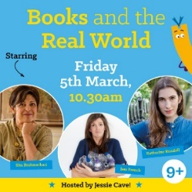
Literacy  Tourist leaflet on The Grand Canyon | Research into The Grand Canyon. Use the link below for a starting point.  Grand Canyon National Park (U.S. National Park Service) (nps.gov)  You need to make sure you have enough information to then plan your tourist leaflet under your chosen sub-headings – for example ‘location’. | Using the template if you wish to – now it is time to produce your own tourist leaflet – remember to use clear sub headings, high level vocabulary, topic specific vocabulary and descriptive language to enhance your writing.  Look at the uploaded ‘persuasive brochure checklist’ to help you | World Book Day  10.30  Follow the link below to listen to a story Events (worldbookday.com)  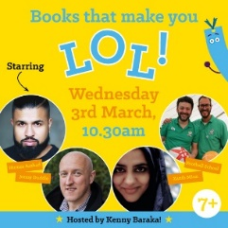  After listening to the audio book, pick one of your favourite books and write an in depth book review – see both prompt sheets to help you. Please watch my morning video for support.
Afternoon Activity/Activities | TOPIC  Have a look at the American Artist – Bruce Gray. He was well known for creating shape illustrations.  Have a go at creating your own art work in his style. Don’t forget to use bold colours.  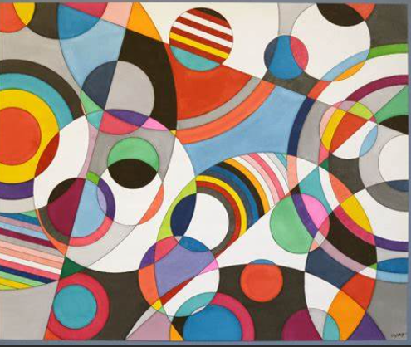 | P.E- Yoga Time  It's Yoga time - SIBFORD GOWER ENDOWED PRIMARY SCHOOL (sibford-gower.oxon.sch.uk)  Reading  30 mins independent reading – this could be a newspaper, information book or a chapter book | World Wildlife Day  A very exciting day for many! Please watch the PowerPoint to launch this special day.  On the last slide is your activity to do- Enjoy!  Reading  30 mins independent reading – this could be a newspaper, information book or a chapter book | French  French & Music - SIBFORD GOWER ENDOWED PRIMARY SCHOOL (sibford-gower.oxon.sch.uk)  To celebrate World Book Day follow the link below to select an audio book to listen to  World Book Day Audiobooks

