Week Commencing  08.02.21  Please watch our video to launch this week’s learning | Monday | Tuesday | Wednesday | Thursday | Friday
Maths  Zoo Maths Project | We have uploaded your daily ‘Zoo Project Maths’  Each day it clearly explains your task and what to do.  Please don’t panic if you don’t finish the task, you can roll over into the next day’s session. |  |  |  | Animal Science- creatures and colour  Watch the ‘live lesson’ (Previously recorded)  Then have a go at completing the booklet.  Primary Science: Creatures and Colour - Live Lesson - BBC Teach
Literacy | Reading Comprehension  Tyger Tyger burning bright  Please read the lovely poem and then answer the questions.  Please don’t feel you need to answer all the sheets provided. | Animal Fact file- research  Pick your favourite zoo animal. Research into the following areas and make brief notes (NOT full sentences):  - Habitat  - Diet  - Social behaviour  - How they live  - Life span  Challenge- threat/endangered | Animal fact file  Use your information from yesterday’s session to create a detailed fact file.  Please make sure you have the following features:  - Title  - Subheadings  - Bullet points  - Image/picture  - Topic related vocabulary | Repetitive Poem  Use the image to inspire you to create a poem which starts with the same sentence stem.
Afternoon Activity/Activities | David Shepherd inspired art  Wildlife Art - David Shepherd Wildlife Foundation  Have a look at the website above. David Shepherd creates beautiful art work.  Your turn- sketch/draw an image in the style of his work.  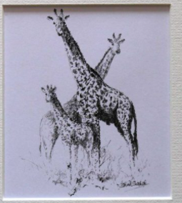 | P.E- Yoga Time  It's Yoga time - SIBFORD GOWER ENDOWED PRIMARY SCHOOL (sibford-gower.oxon.sch.uk) | 3D Art  Using a range of different materials, create a 3D zoo animal.  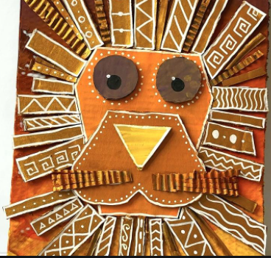  Below is an example using cardboard and paint. | French  French & Music - SIBFORD GOWER ENDOWED PRIMARY SCHOOL (sibford-gower.oxon.sch.uk) | 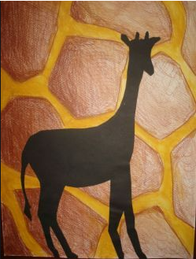  Animal silhouettes  Finish with a film or you tube clip connecting to the zoo  Lion King, Madagascar, The Wild, Zootropia

