Week Commencing  11.1.21 | Monday | Tuesday | Wednesday | Thursday | Friday
Maths | Venn Diagram  Work through the power point that I have uploaded onto purple mash- I have recorded my voice to help support you.  Pick the activity that you feel comfortable to complete.  Mild- Supported Venn Diagram  Hot- 4 and 9 times table  Spicy- Create your own Venn diagram  Super Spicy- Venn diagram with three circles.  - Challenge sheet- mastery questions | Line graph  Work through the power point that I have uploaded onto purple mash- I have recorded my voice to help support you- enjoy.  Use the data to create your own line graph  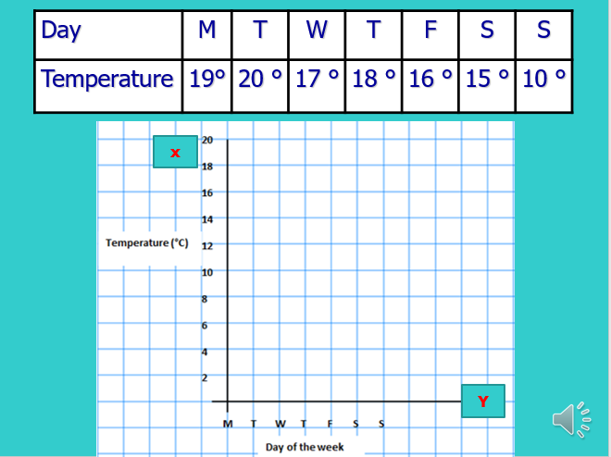  - Challenge, super spicy. Complete the mastery questions | Bar Graph  Interrupting bar graphs  Using the bar graph provided, complete the questions. Don’t forget to answer in full sentences.  Mild and Hot- 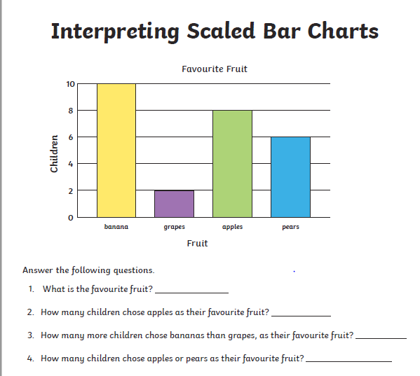  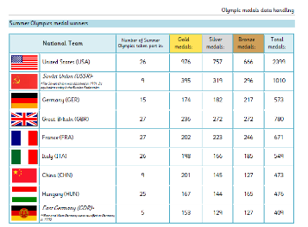  Spicy and super | Arithmetic  We do this weekly in class so to keep constituently we will be continuing with this every Thursday morning | This week we are setting you the challenge of making an ‘underwater volcano’  Challenge Cards (jamesdysonfoundation.co.uk)
Literacy  Persuasive writing  You are going to create a piece of writing to persuade an Anglo Saxon warrior to buy your weapon. | Reading  Inference activities  Have a look at the power point, some of you may wish to work through the activities in order and some of you may want to pick the ones you feel happiest doing.  You can answer verbally or write your answers down. | Today I would like you to finish completing the Success Criteria grid just as we do in class.  Please feel free to research features, vocab etc to help you. Make it as detailed as possible as this will help your planning tomorrow. | Plan  Today, can you please plan your piece of writing  Here are some prompts to focus your planning (you do not need to use them, make your own up)  - What is your weapon made of?  - Type of weapon – attack or defence weapon?  - Interesting selling points  - Safety features  We have also attached two sheets with help and ideas to add to your writing – make sure you look at them. | Write  Today you are going to write your piece of writing. As always re-read your plan before you start. We have attached a couple of examples for you to look at before you start. If you can, have a look and remind yourself of the success criteria.  Enjoy, I cannot wait to see your finished writing.
Afternoon Activity/Activities | SAXON Warriors Quiz-  Can you answer the following questions? Please write down your answers and you may use resources to help you.  - What weapons did they use?  - What materials were commonly used?  - When did they use their weapons?  - Did they have specific weapons for different uses?  - How were they made? | P.E.  ‘Climb the ladder’  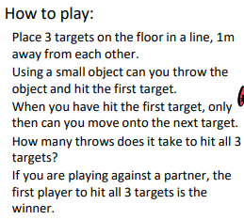  Top tips: Throwing underarm  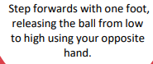  Plan and design your own weapon.  Your plan must have the following features.  Clear and detailed labelling.  A list of materials needed  An illustration- with colour  - Challenge: explain in steps how you plan to make your weapon. | Create your weapon  From your plan, collect all of the materials you will need to complete your weapon.  You could use outdoor materials, paper and cardboard or any other materials that you have at home.  Think outside the box and be creative! See the examples below for some inspiration. | Willow  Quiz: https://forms.gle/jcYynpbHiYutaZ2z6  Video: https://youtu.be/Nktr1g6hsnI | Global Learning  Have a look at the newspaper and photo questions. Have a discussion about what is going on in the picture.  Don’t forget this is all uploaded on to your purple mash portal!
Helpful links, websites or suggestions | Ashmolean Museum: Anglo-Saxon Discovery - Weapons (ox.ac.uk) | 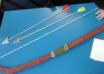 | 