Week Commencing  18.1.21 | Monday | Tuesday | Wednesday | Thursday | Friday
Maths | NRICH investigation  The idea of this activity is for you to decide whether each of the number sentences below is true or false.  Try not to use written calculations, think about your reasoning and write it down or talk to someone else about your ideas. | Area  Work through the power point that I have uploaded onto purple mash- I have recorded my voice to help support you- enjoy  Mild and Hot-  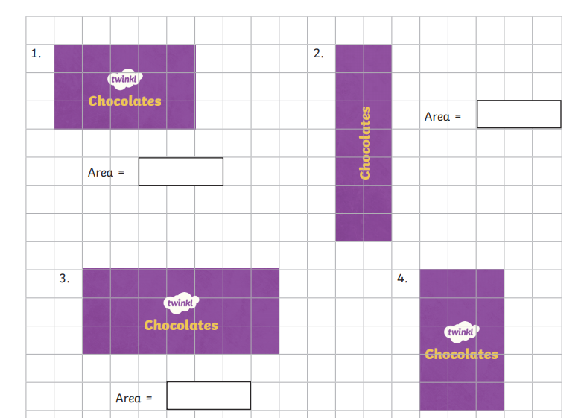  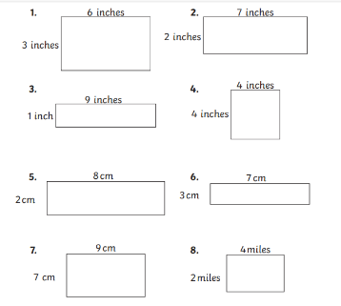  Spicy-  Super Spicy- Area word problems | Comparing area  Refresh yesterday’s PowerPoint if you need too  Mastery challenge- I have uploaded a challenge sheet for you to have a go at. There are many questions so please don’t feel you need to complete it all.  Today is about comparing different areas and explain why one is larger or smaller.  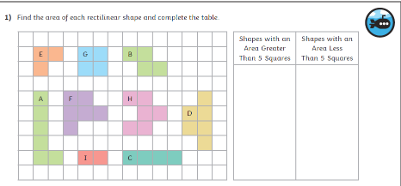  Don’t forget to use our magic word ‘because’ when answering your questions. | Arithmetic  We do this weekly in class so to keep constituently we will be continuing with this every Thursday morning | This week we are setting you the challenge of making a ‘Tornado in a bottle’  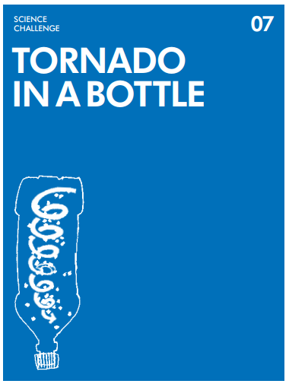  Challenge Cards (jamesdysonfoundation.co.uk)
Literacy  Character Description  You are going to create a character description of an Anglo Saxon warrior using adjectives, simile’s and metaphors. | Reading  ‘All about Alfred the Great’ comprehension activity  Read the text and then answer as many questions as you can. Remember to answer in full sentences and also remember ‘quality not quantity’ | Watch ‘Alfred the great’ clip  Who was Alfred the Great? - KS2 History - BBC Bitesize  Alfred the Great for children | King Alfred KS2 homework help | TheSchoolRun  Do some research on Alfred the Great using the links above. | Plan  Now it’s your turn- create your own ‘Anglo Saxon Character’ (king, warrior or peasant)  Use the prompts below to help you.  What is your character’s name, how old are they and what do they do in their spare time?  What does your character look like? Think about his/her hair, eyes, size. (Please feel free to draw your character)  What kind of person is your character? Are they  funny, happy angry?  Do they have any hobbies?  Is there anything extra ordinary about your character? | Write  Watch the PowerPoint before you start and then you are ready to write your own character description – remember to use your plan and the prompt sheet of high level vocabulary.
Afternoon Activity/Activities | The topic focus this week is ‘Runes’.  We would like you research into what ‘Runes’ are.  We have uploaded some pictures to help you. | P.E.  Yoga – https://9313005-my.sharepoint.com/:v:/r/  personal/rhiannon_perkins_sibford-gower_oxon_sch_uk/Documents/Acorn%20Lockdown/  Yoga%20videos/Yoga%20week%20beginning%  2011th%20jan.mov?csf=1&web=1&e=BQpWJm  Copy and paste the link into your search bar to see a fabulous yoga session by Mrs Perkins. | Time to go outside  Using your research from Monday’s session, we would you to use natural materials to make your name using ‘Runes’.  Be creative- you could even make your friends and family members names.  We have uploaded the ‘Runes Alphabet to help you’. | French | Global Learning
Helpful links, websites or suggestions

