Week Commencing  22.02.21  Please watch our PowerPoint to launch this week’s learning and our NEW TOPIC! | Monday | Tuesday | Wednesday | Thursday | Friday
Maths | 2D  Watch the PowerPoint to refresh your mind with 2D shapes.  Have a go at the two sheets provided.  - Name the 2D shapes  - Identify the properties | 3D shapes  Use the PowerPoint to introduce 3D shapes.  Then have a go at completing the sheets attached. Please pick the sheet that you feel most comfortable completing.  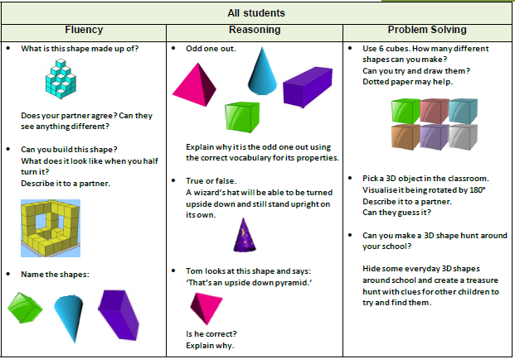 | 2D and 3D shapes  Create a game which has a range of 2D and 3D shapes.  Refer back to the powerpoints before you start.  Ideas-  Top trumps cards  Shape monoply  Guess the shape game show  Shapes and ladders (snakes and ladder style) | Arithmetic  We do this weekly in class so to keep constituently we will be continuing with this every Thursday morning. | Spellings- these have been uploaded onto your Purple Mash  Science  Inertial Eggs  JDF-challenge-cards-JULY20.pdf (jamesdysonfoundation.co.uk)
Literacy  Postcards | Power point to launch new topic- Flying to USA  Time to visit the  BIG APPLE  Watch the video below and make brief notes as you go  Experience new York city in Virtual Reality (youvisit.com)  When you are watching the video clip note down the following answers:  What do you see?  How did you there?  How are you feeling?  What is the weather like?  Are there any similarities or differences in comparison to your home town? | Researching NEW YORK  Find out about 5 key places, locations or things to do in New York.  For each one, create a brainstorm of key descriptive vocabulary to go with each one.  We have up loaded some images to help inspire you onto the powerpoint  New York Pictures and Facts (nationalgeographic.com) | POST CARD TIME…  Now you have been to New York and are enjoying your time there, you need to write a post card home.  Think about the following features when writing your post card.  - Who are you writing your post card to?  - Explain about the places you have seen and been (in detail)  - Describe how you are feeling.  Examples are on the PowerPoint for you. | Reading Comprehension  ‘Journey to America’
Afternoon Activity/Activities | TOPIC  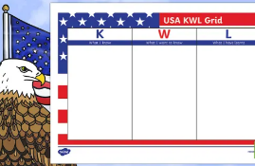  At the beginning of a new topic, we always collect ideas about what you know and what to know.  The united states of America- Use the table provided to find and locate all of the 50 individual states. | P.E- Yoga Time  It's Yoga time - SIBFORD GOWER ENDOWED PRIMARY SCHOOL (sibford-gower.oxon.sch.uk)  Reading  30 mins independent reading – this could be a newspaper, information book or a chapter book | TOPIC  Research into a traditional American dish- you could even cook it if you wish (I am!)  American recipes - BBC Food  Reading  30 mins independent reading – this could be a newspaper, information book or a chapter book | French  French & Music - SIBFORD GOWER ENDOWED PRIMARY SCHOOL (sibford-gower.oxon.sch.uk) | Global Learning  Have a look at the picture news for this week. Discuss and share your opinions.

