Week Commencing  25.1.21 | Monday | Tuesday | Wednesday | Thursday | Friday
Maths | Perimeter  This week we are focusing on perimeter. Please follow the PowerPoint first to help support your learning.  Then there are three activities for you to pick from. Mild, hot and spicy.  Don’t forget to pick the level you feel most comfortable with. | Perimeter  Perimeter ‘Snakes and Ladders’ board game. This is a fun game to play either with an adult or with your brother or sister- Enjoy | Perimeter  Diving into mastery. Again pick the questions you need to do and remember to ‘think about your thinking’. | Arithmetic  We do this weekly in class so to keep constituently we will be continuing with this every Thursday morning | This week we are setting you the challenge of making a ‘Cardboard Chair’ (p.57)  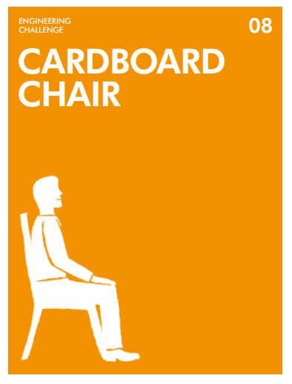  Challenge Cards (jamesdysonfoundation.co.uk)
Literacy | Reading Comprehension  Please see the uploaded file – read the poem and then answer the questions (using full sentences). This week we are focussing on Poetry | Grammar  SPAG MATs  Uploaded onto your purple mash is your SPAG mat.  I have added a support sheet to help you. | Features of instruction writing  Please follow the PowerPoint uploaded and look at the example. Then with a sibling or adult discuss how you made your birdfeeder (Speaking and Listening). If you want to make notes in preparation for tomorrow the please do. | Write your instructions your bird feeder  Create your own detailed set of instructions remembering all the features needed.  Please refer back to yesterday’s PowerPoint if you need support
Afternoon Activity/Activities | TOPIC  Please see attached sheet for todays and Wednesday’s session.  ‘Drawing inspired by Anglo Saxon Architecture’ | P.E.  It's Yoga time - SIBFORD GOWER ENDOWED PRIMARY SCHOOL (sibford-gower.oxon.sch.uk)  In preparation for ‘The Big Garden Birdwatch’ we would like you to make a birdfeeder | TOPIC  ‘Sculpture with personality inspired by Anglo Saxon Houses’ – this session follows on from Mondays | French  Click on the link below for your French lesson with Mr Cameron  Don’t forget to complete your quiz afterwards  French & Music - SIBFORD GOWER ENDOWED PRIMARY SCHOOL (sibford-gower.oxon.sch.uk) | Global Learning  Have a look at the newspaper and photo questions. Have a discussion about what is going on in the picture.  Don’t forget this is all uploaded on to your purple mash portal!  Class book

