Week Commencing 4.1.21 | Wednesday  6.11.21 | Thursday  7.1.21 | Friday  8.1.21
Maths  *Friday – science (Children are used to doing science on Friday mornings so we are keeping this to help them) | I'm Eight  When I went into a classroom earlier this week a child rushed up to tell me she was 8 that day.  Well, Happy Birthday to everyone who has a birthday today!  This challenge is about finding a variety of ways of asking questions which make 8.  You might think of 6 + 2, or 22 - 14 or...  However, try to create examples that use all the different mathematical ideas that you know about.  Perhaps you could challenge yourself to find ways of making 8 that you think no-one else will have thought of.  If you are not 8 years old, you might like to use your age instead of 8. | Buying a Balloon  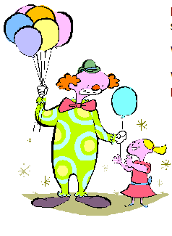  Lolla bought a balloon at the circus. She gave the clown six coins to pay for it.  What could Lolla have paid for the balloon?  Which of your answers seems a reasonable amount to pay for a balloon?  - Challenge: Lolla bought 3 balloons at the circus. These came to a total of £3.20.  What coins did she use? | Science- we will be having a focus on investigations and key vocabulary.  Every Friday we will be setting an investigation for you to complete  This week we are setting you the challenge of building a boat that can hold a bag of sugar without sinking!  (You can test this in your bath or sink)  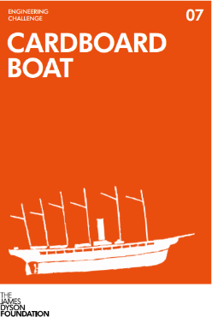
Literacy | Our new topic this term is…  ‘Traders and Raiders’  We are going to be learning about the Anglo Saxons.  Use this session to research all about Anglo Saxons. Make notes as you go, as you will be using them to design an information fact file or poster. | Reading Comprehension  We have been working hard on our skills to complete these. Don’t forget to read the questions and underline key words.  Please see this week’s zip file for the task.
Afternoon Activity/Activities | Use your research from this morning and present your facts in a format of your choice.  Don’t forget to make it eye catching, formative, and full of interesting facts.  Feel free to add illustrations.  (information poster, presentation, story board or mind map) | Anglo Saxon Time line  Use the support sheet to create your own time line.  Don’t forget to order in chronological order and be clear with your dates.  You can create and set out your timeline in a format that works for you.  Be creative | PE- create your own fitness circuit either outside or indoors.
Helpful links, websites or suggestions | History KS2: Anglo-Saxon Britain (animation) - BBC Teach  Who were the Anglo-Saxons? - BBC Bitesize | Help sheet- Zip file  W/C 4.1.21 | Challenge Cards (jamesdysonfoundation.co.uk)

